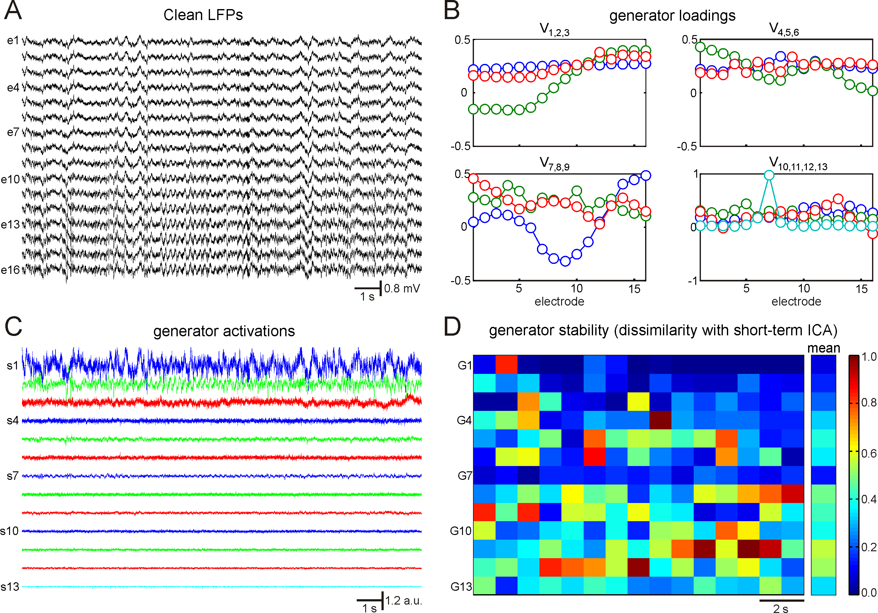
sFig. 3: Identification of stable LFP generators. A) LFPs after suppressing extrinsic sources. B,C) ICA of clean LFPs over whole 15 s time interval (about 190 pts/weight). Thirteen components have been obtained (16 channels minus 3 constraints reducing the data dimension; see also the main text). Some components have non-smooth voltage loadings, which suggests their possible noisy origin. The last generator (G13) isolates somatic spikes, its voltage loading (V₁₃) has well pronounce peak at the 7-th electrode (soma position). D) Test of the stability of the found "global" generators. Short-term ICA over 1 s time windows has been performed. Then local independent components ("local" generators) have been compared to the "global" generators (shown in B). Color from blue to red corresponds to the found dissimilarity (Eqs. 4 and 5 in the main text) between the closest "local" generator and the corresponding "global" generator (from G1 to G13). The right inset (marked as "mean") shows the averaged dissimilarity between "local" and "global" generators. Four generators (G1, G2, G3, and G7) can be selected as the most stable. Inspection of their loadings (B) shows that all of them are smooth enough, i.e., their CSD are localized in space and consequently can correspond to synaptic terminals onto pyramidal cells.

